Avengers Game Collection Final Report

**Description of Project:**

A game collection for casual entertainment & leisure that includes Checkers, Sudoku, Coin Flip, Guess Number and Counter.

Checkers:

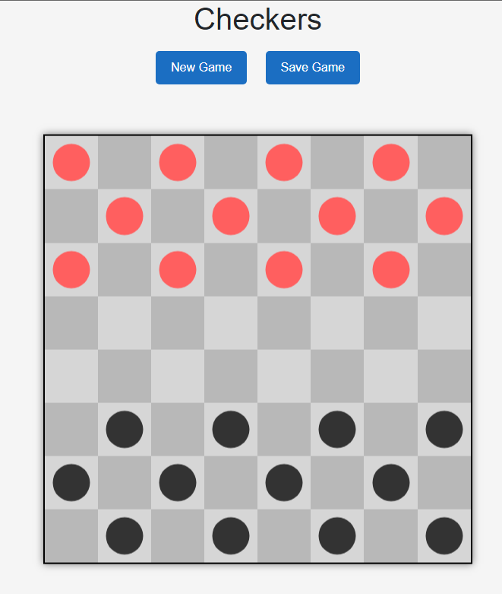

Sudoku:

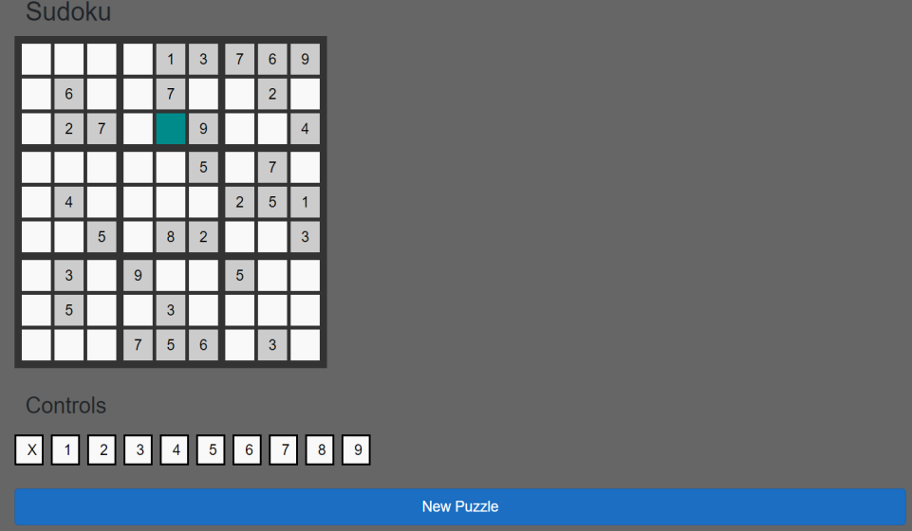

Coin Flip:

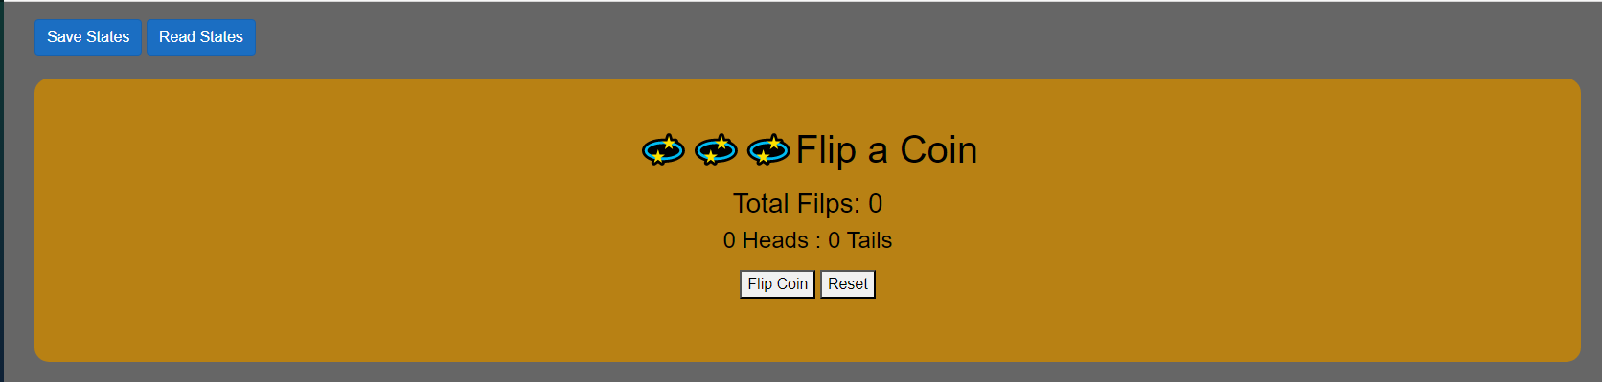

Counter:

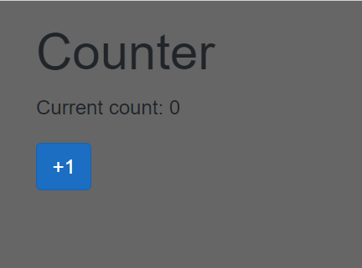

Guessing Number:  
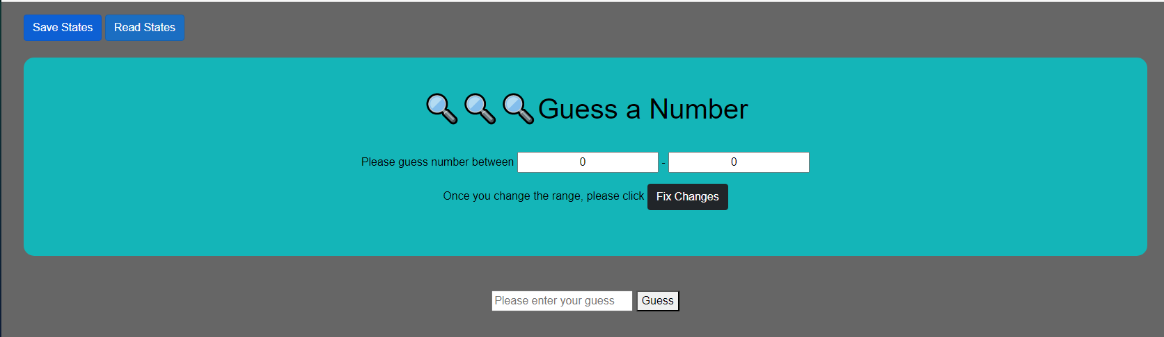

**How to install:**

**1.**Go to our Github at <https://github.com/BrendenAldridge124/AvengersGameCollection/tree/branch_by_Xia_v3>

and **download the code as a zipped folder and unzip it**

**2**.Open Visual Studio and click “open a local folder” and select the above unzipped folder.

**3.**Open the code in Visual Studio, and double click “AvengersGameCollection.sln”

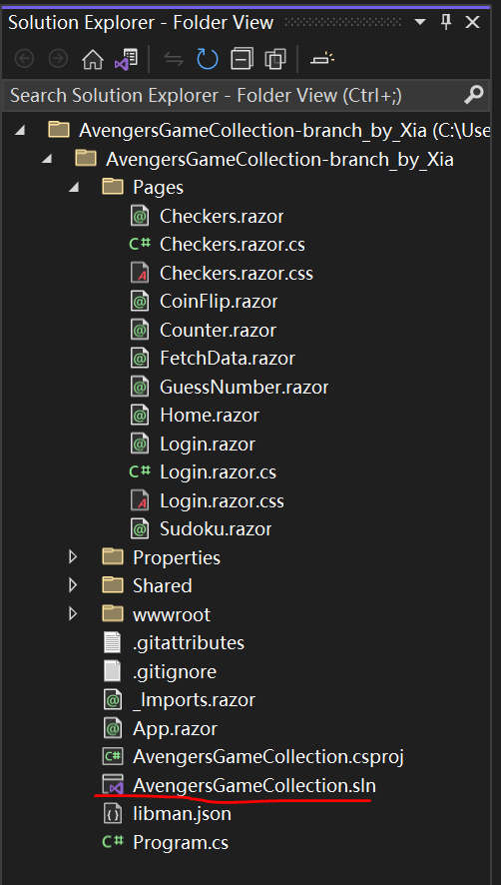

**4.** To use the API for serialization purposes, downloading the library for local storage is needed. Right click “AverngerGameCollection” and click the “Manage Nuget Packages..”

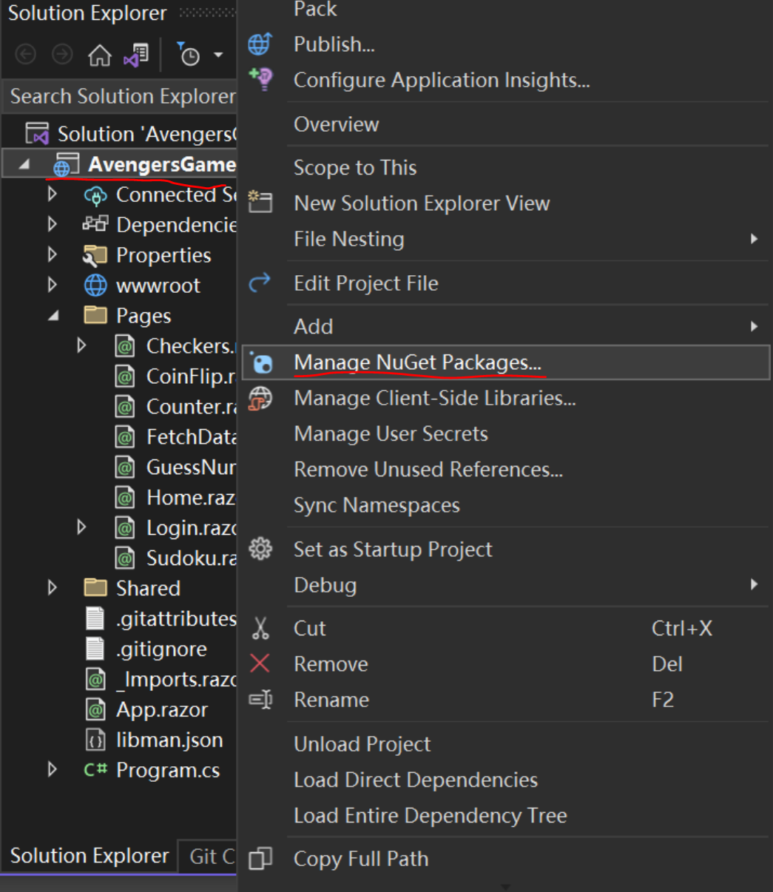

Search and install two libraries as below: “Blazored.LocalStorage” and “Blazored.SessionStorage”

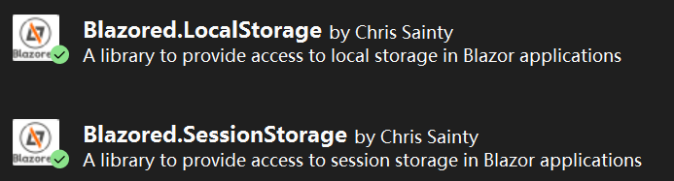

**5.** Press the play button circled below

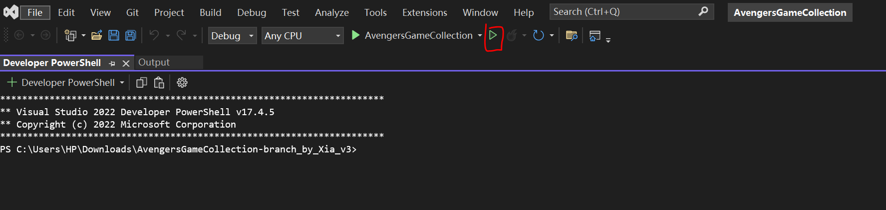

**6.** The game can then be installed locally as a PWA (Progressive Web Application) by clicking here.

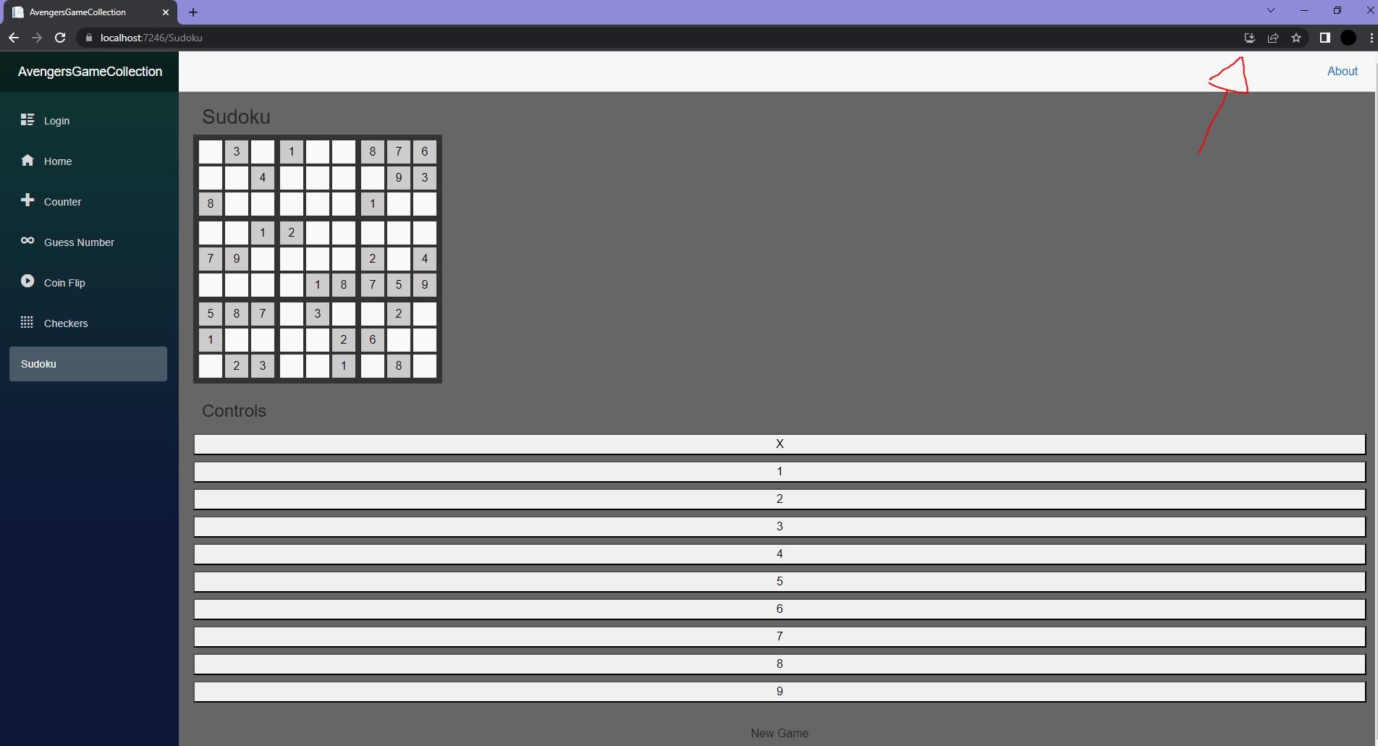

**7.** By clicking in the upper right corner of the browser and click “more tools” and “create shortcut”, a shortcut on the desktop will be generated as below, which provides quicker access for users to play next time.

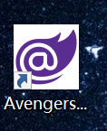

**User manual:**

**Game 1. Counter**

Counter is a game for players to count numbers.

Click “Counter ” on the left bar and then click “+1” as below to realize the counter function.

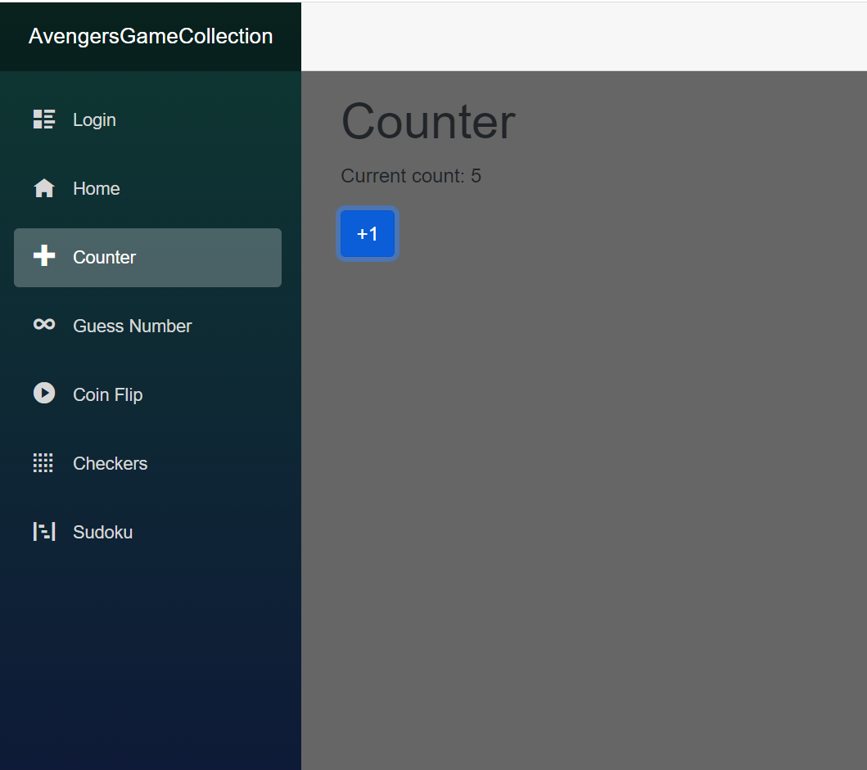

**Game 2. Guess Number_Developed by Xia**

“Guess Number” is a game for players to guess a certain number within a given minimum and maximum range.

Click “Guess Number” on the left bar, input two numbers in the blanks on top and click the “Fix changes” button. Once the color changes, enter the guess in the lower box and click the “Guess” button.

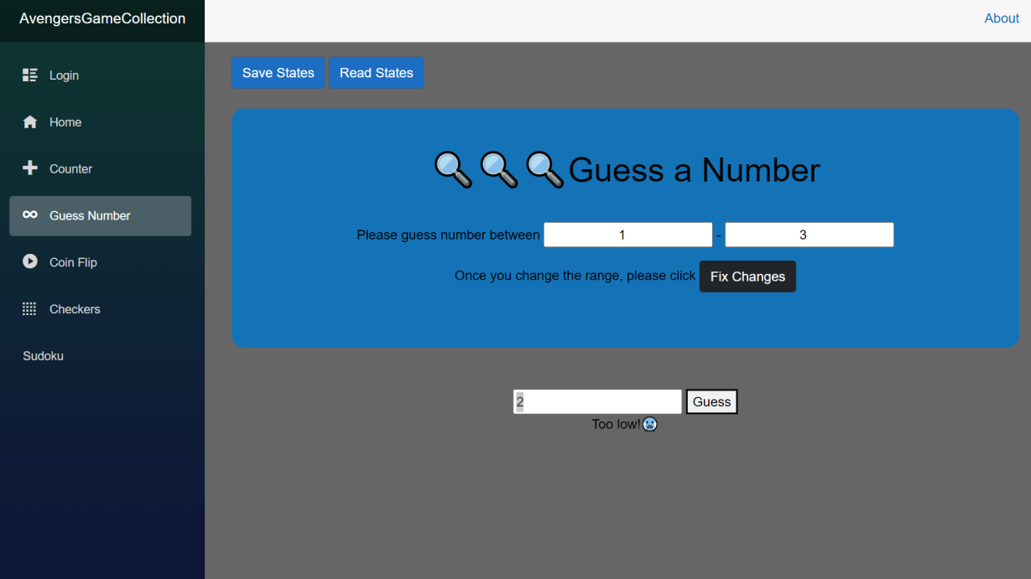

Like the above image, if the guess is too low, please input a larger number. If the guess is too high, please input a smaller number. If the guess is correct, the game will show the message “Correct!” and display your guess history and number of attempts at the bottom. If you want to play again, please click the “play again” button.

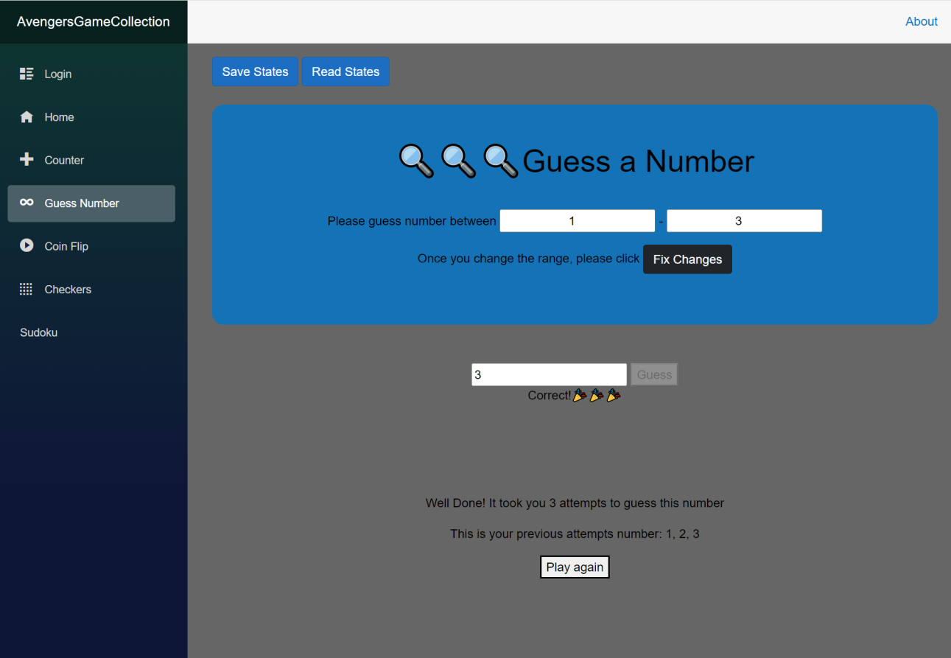

Serialization: If you want to save and revisit your minimum and maximum range next time, please click the “Save States” button.

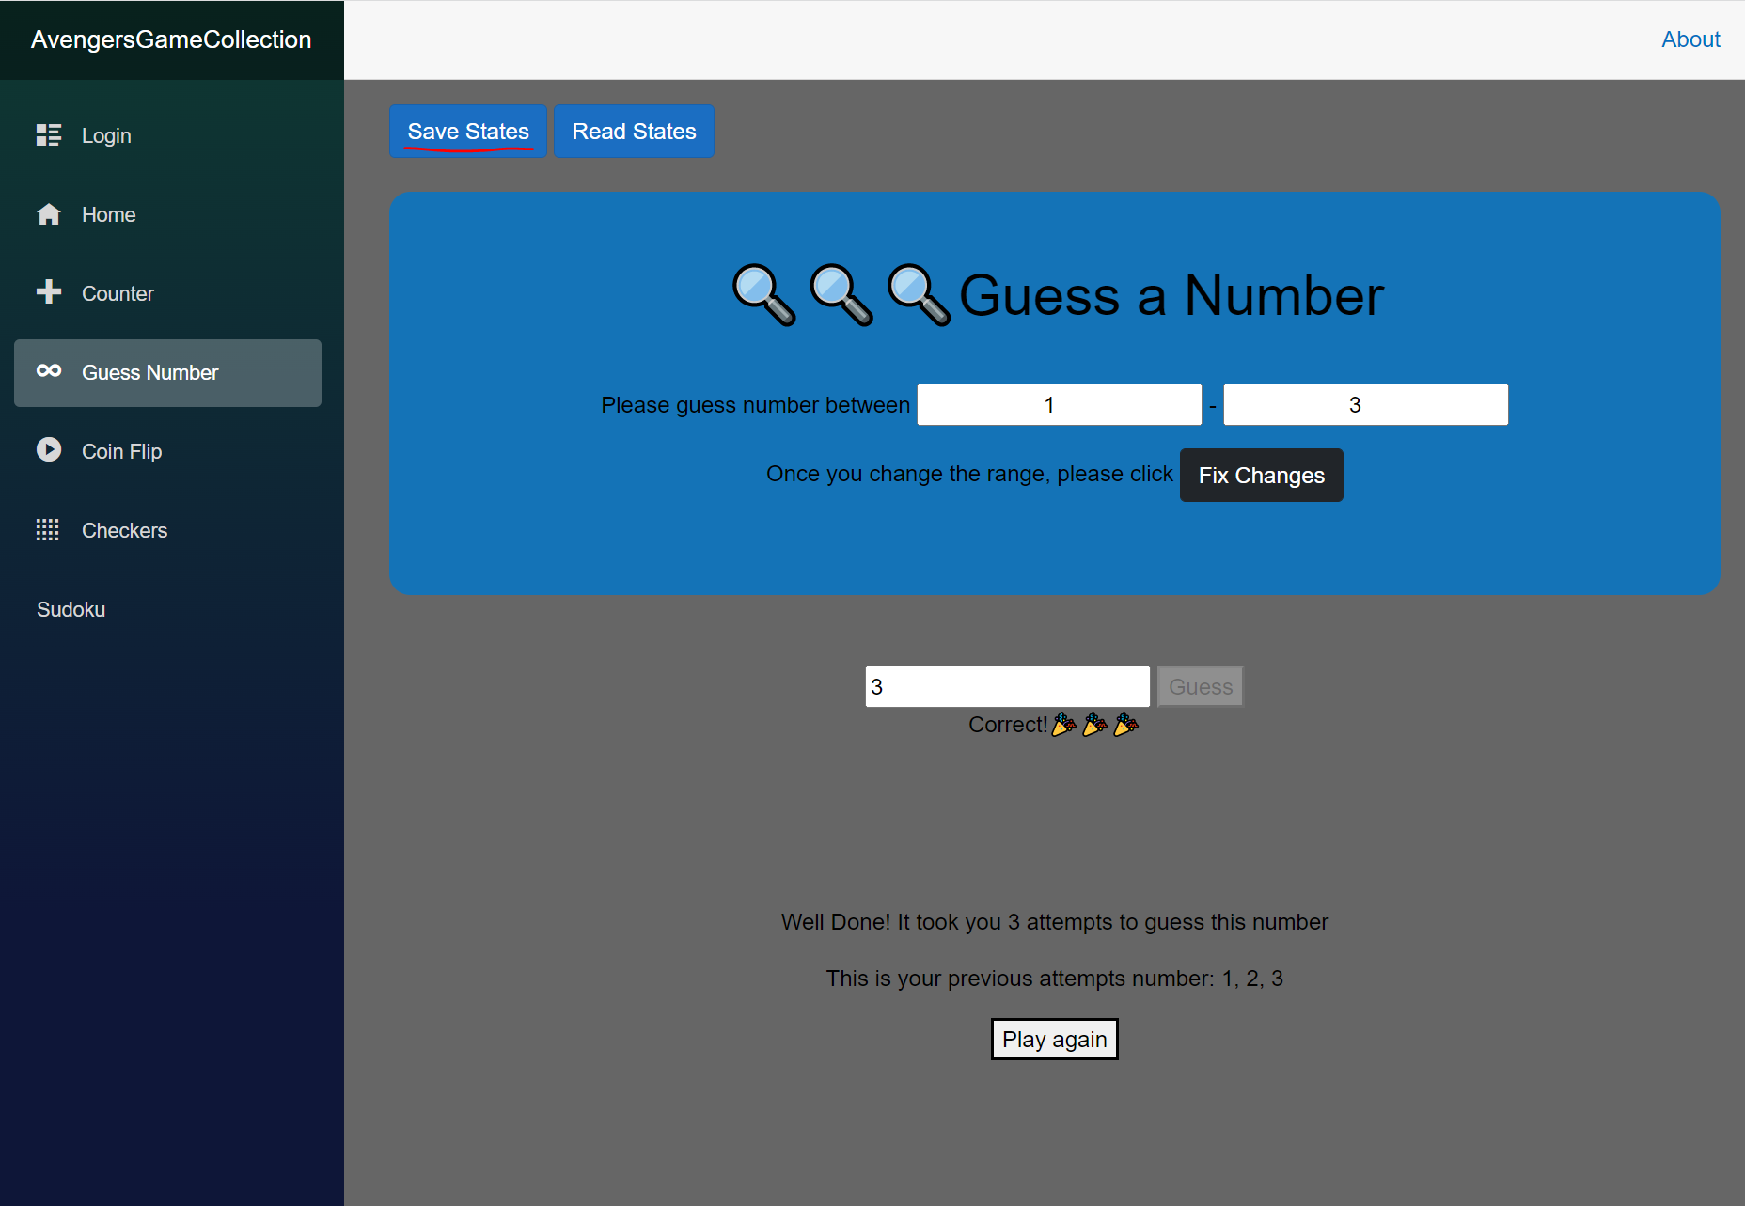

Now you can close the browser tab and rerun the play button in visual studio as before (or click the shortcut you created for AvengersGameCollection on the desktop). Then you can click the “Read States” button to revisit your data (minimum and maximum range) from last time stored in the local storage as in the image below.

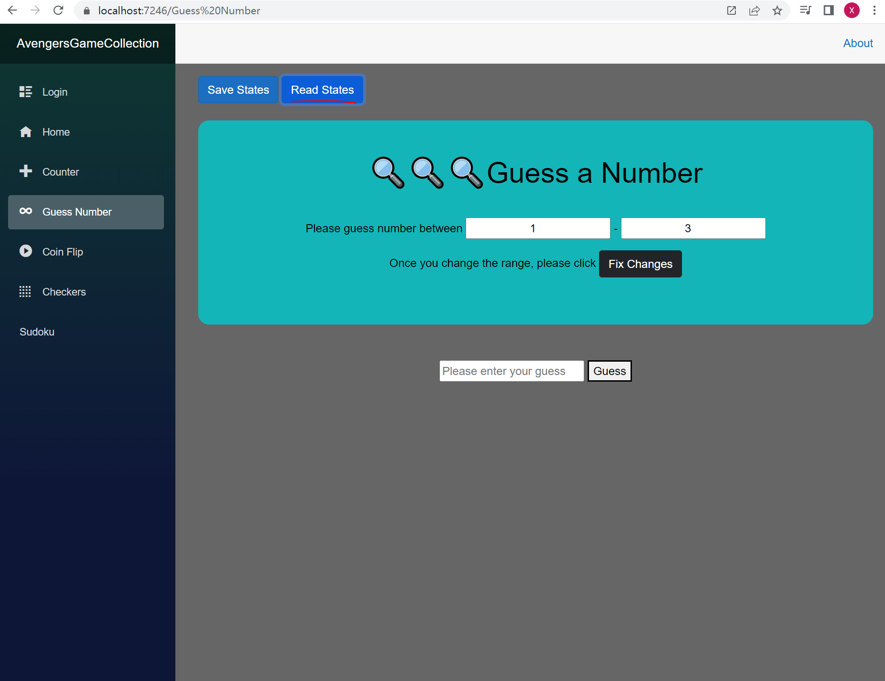

**Game 3. Coin Flip_Developed by Xia**

“Coin Flip” is a game for players to flip a virtual coin and record the history for coin flipping.

Click the “Coin Flip” button on the left bar and then click the “Flip Coin” button to flip a coin. And click the “Reset” button to flip another coin. If a user wants to test the probability of coin flipping 100 times or even more, then he can track the history in this app.

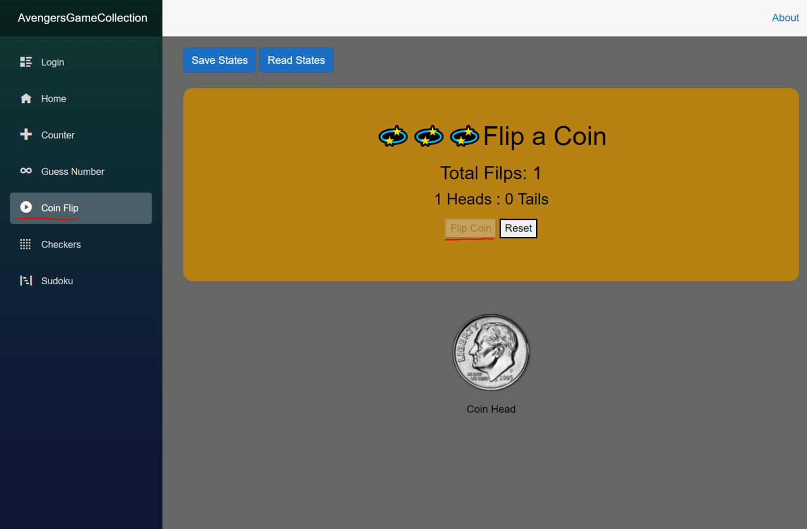

Serialization: If you want to save and revisit your past coin flip history, click the “Save states” button now.

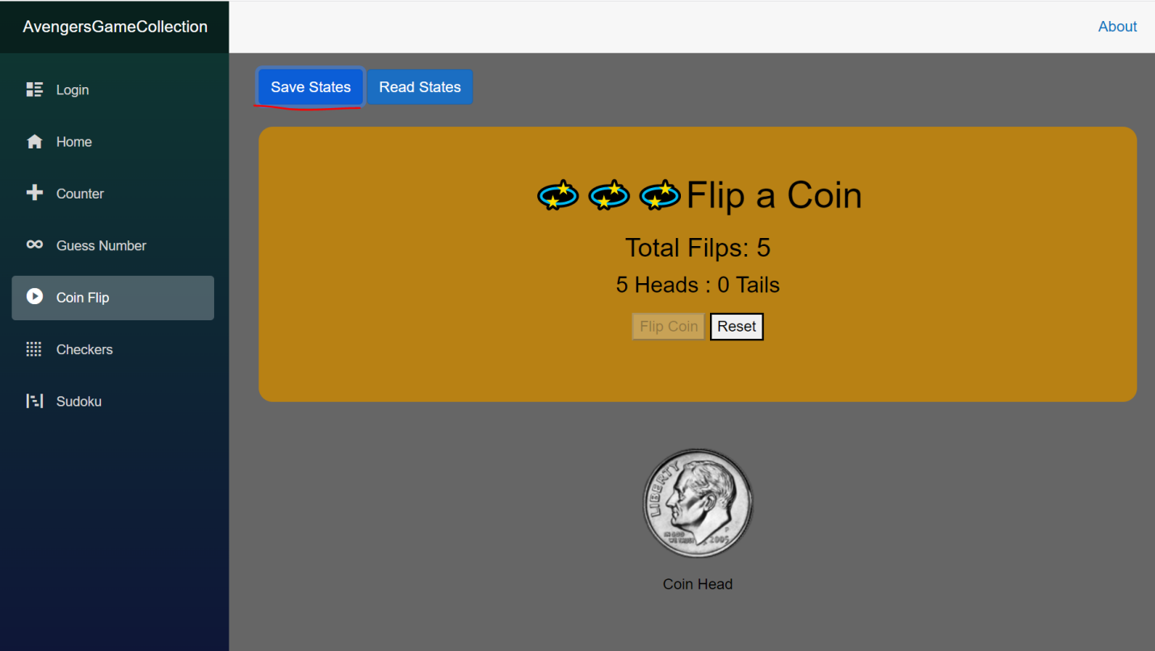

Then close the browser tab and hit the play button again in visual studio (or click the shortcut you created for AvengersGameCollection on the desktop). Now go to the “Coin Flip” page and click the “Read States” button and past coin flip history will be shown as below.

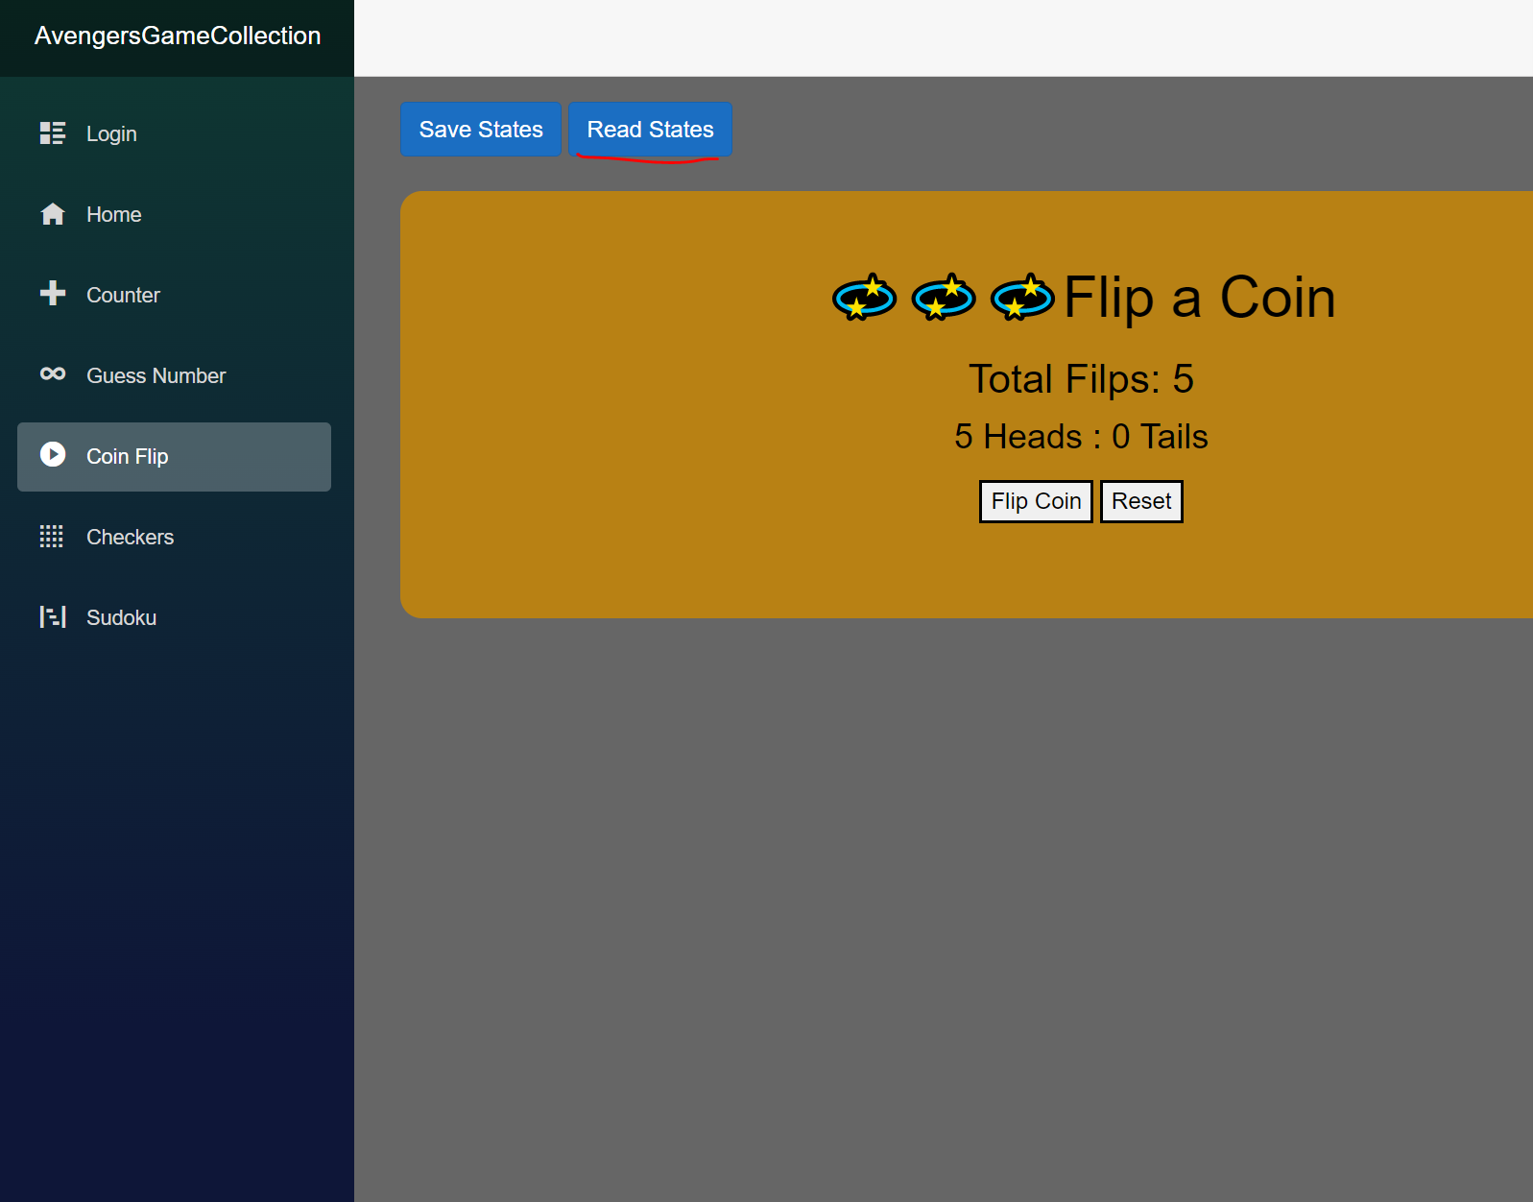

**Game 4. Checkers_Developed by [Brenden](https://github.com/BrendenAldridge124)**

Checkers is a two player game, where two players compete to eliminate all the other players' pieces.

Controls: To start the game have both players decide which color they will be, red goes first.

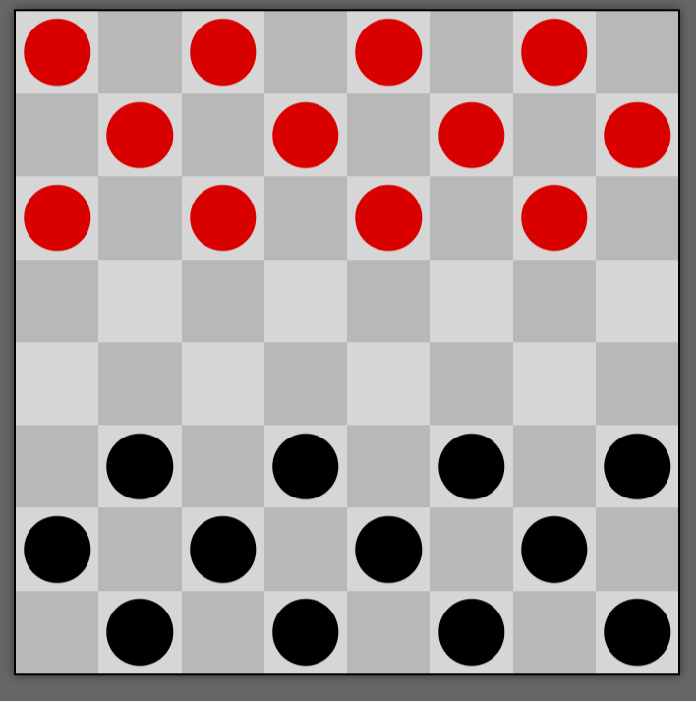

To move a piece you must click on it and then click one of the green spaces.

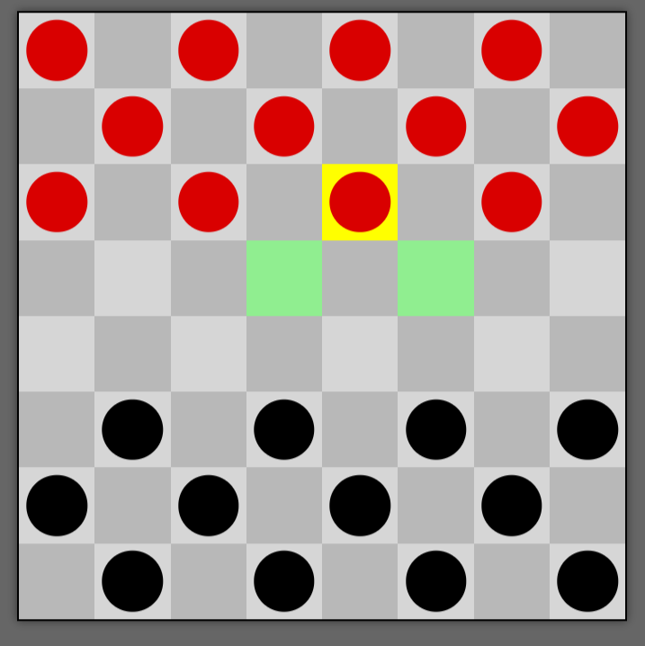

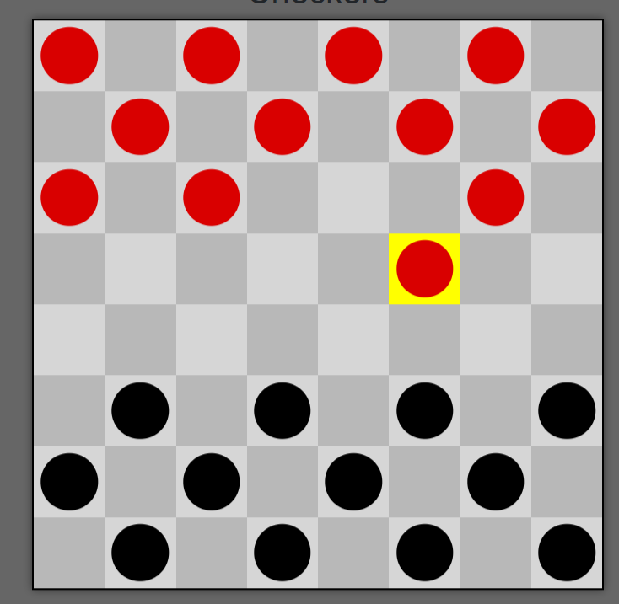

To take a piece you must have one empty space diagonal from the piece then move your piece to that square

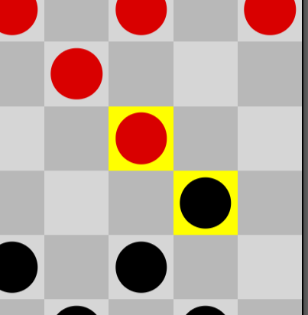

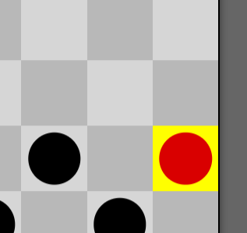

To start a new game please refresh the page.

**Game 5. Sudoku_Developed by Zack**

Sudoku: A puzzle game that has a 9x9 square and must have numbers

1-9 inserted also no numbers repeated in the columns or rows.

Controls: Click a tile to select it

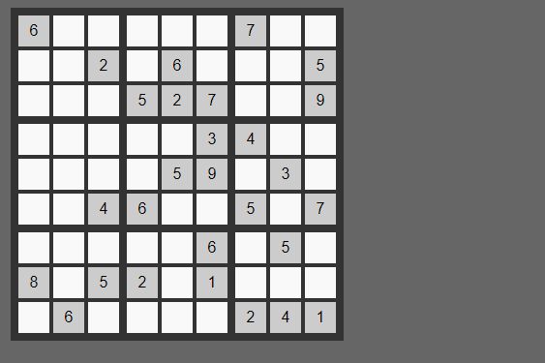

Then click one of the numbers to place it.

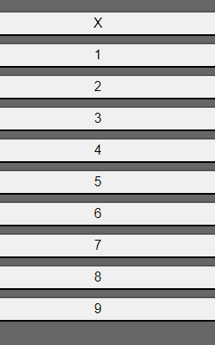

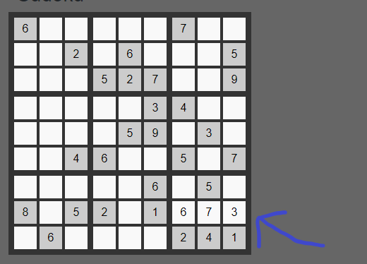

Then the x clears the selected tile.

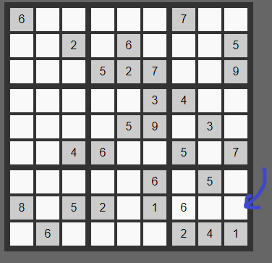

To start a new game hit the new game button

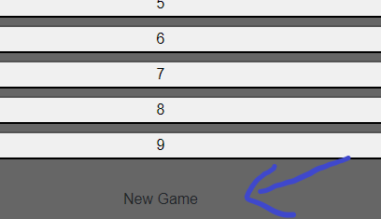

**Appendix about API used in Local Storage Library:**

Blazored LocalStorage library provides Blazor app developers to achieve the local storage function when developing web apps. In addition, it helps to handle the serialization and deserialization functions. For Blazor WebAssembly developer, following APIs are available and used in “Coin Flip'' and “Guess Number” games:

API: asynchronous via ILocalStorageService:

o SetItemAsync()

o GetItemAsync()

o RemoveItemAsync()

The advantage of local storage APIs is that it helps to store the user data across all sessions. Even if the user closes the browser tab, the user can still access the data stored in local storage when they revisit the app.